OpenERP caldav(Calendar synchronizing):

What is CalDAV?
CalDAV is Calendaring Extensions to WebDAV, means it is an Internet standard allowing a client to access scheduling information on a remote server.

CalDAV in OpenERP
OpenERP Caldav modules(base_calendar and caldav) provides following functionality:
- Event and Todo Synchronization
- Event and Task Reminder
- Sending Invitation to people via mail
- Fetching attendee response using mail gateway
- Event Alerts
- Recurring Events
- Webdav server that provides remote access to calendar
- Customize calendar event and todo attribute with any of OpenERP model

With OpenERP caldav module(s) you can use/share and synchronize OpenERP events and tasks to any remote calendar. And changing data to remote calendar will reflect to OpenERP.

How it works?
First we will see how to configure calendar for Import/Export with OpenERP models and fields.

Here is the form view of calendar from menu Sales/Configuration/Calendar/Calendar.

You can Define calendar's line and its related Object to which you want to map calendar event.
By default it maps events to “Meeting Cases” from crm_caldav module.

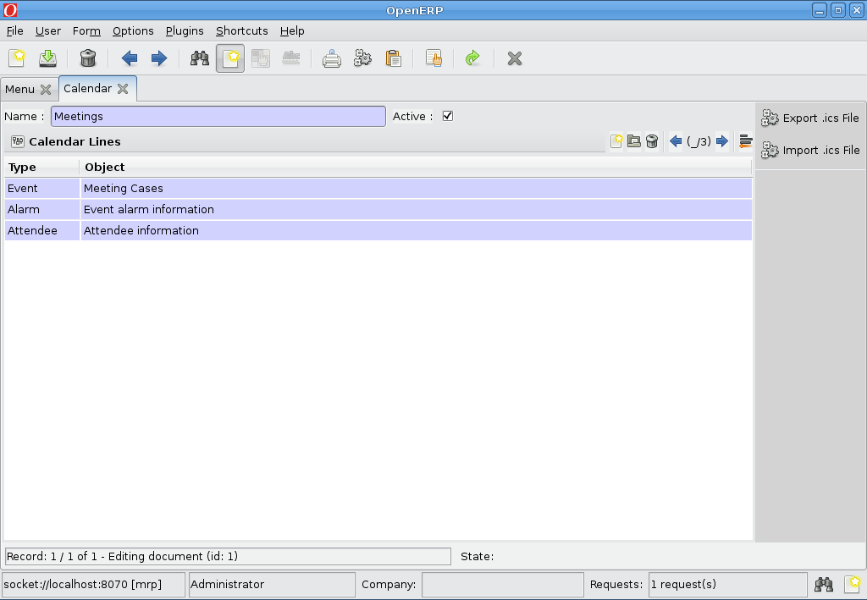
Caldav attribute's mapping:
You can define mapping of Caldav attributes to OpenObject model's fields in “Attribute Mapping” like:
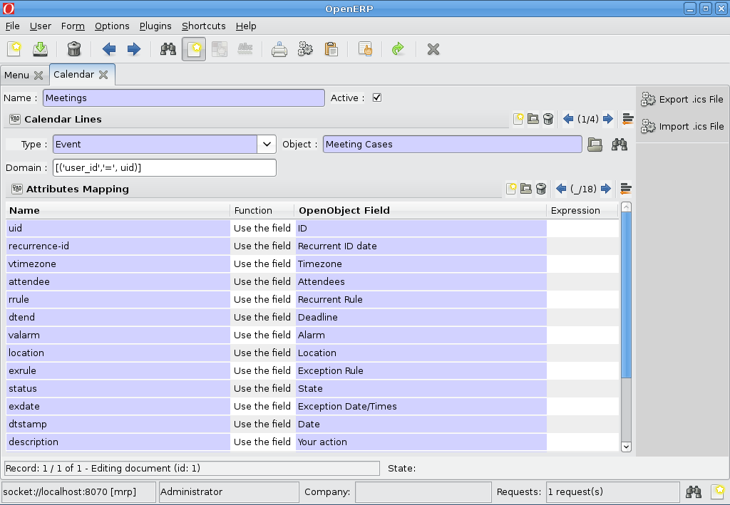

Here you can see the wizards to Import/Export calendar data.
You can also subscribe to any Shared Calendar using wizard “Subscribe”.

Exporting Calendar Data:

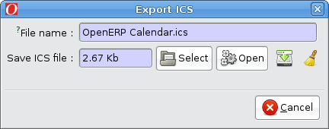
This is a dialog that will be opened when you click on Export .ics, You can save exported .ics files and use it in any caldav system that supports importing .ics files.
Importing .ics file:

You can import valid .ics files from “Import .ics File” wizard.
It will Create new event and todo if its exported from calendar other than OpenERP calendar.
Or it will update data event and todo if has been exported from “Export .ics File” wizard.

Subscribe to remote calendar:

You can import remote calenadr from “Subscribe” wizard from Calendar.

Meetings Calendar:

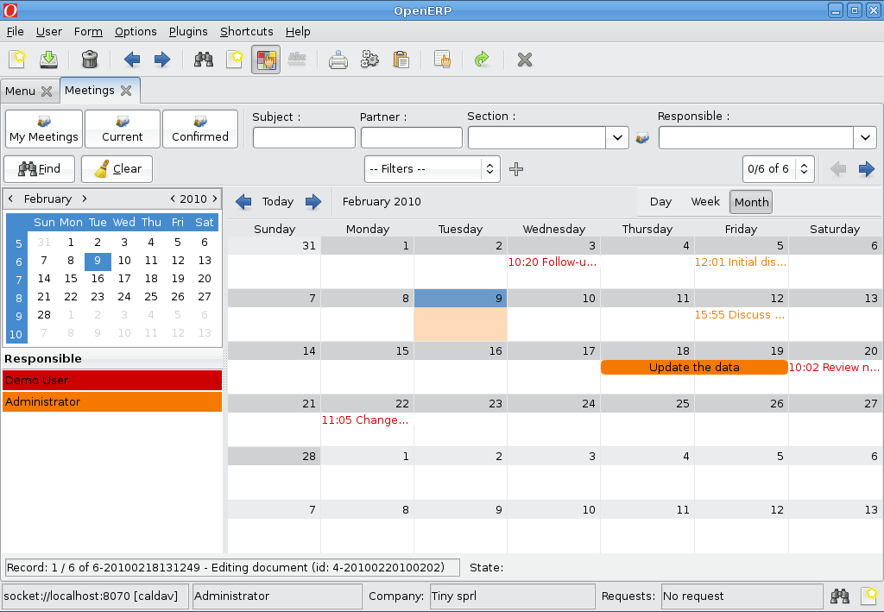

Recurrent meetings:

You can define recurrency on meeting by defining “Recurrency”.

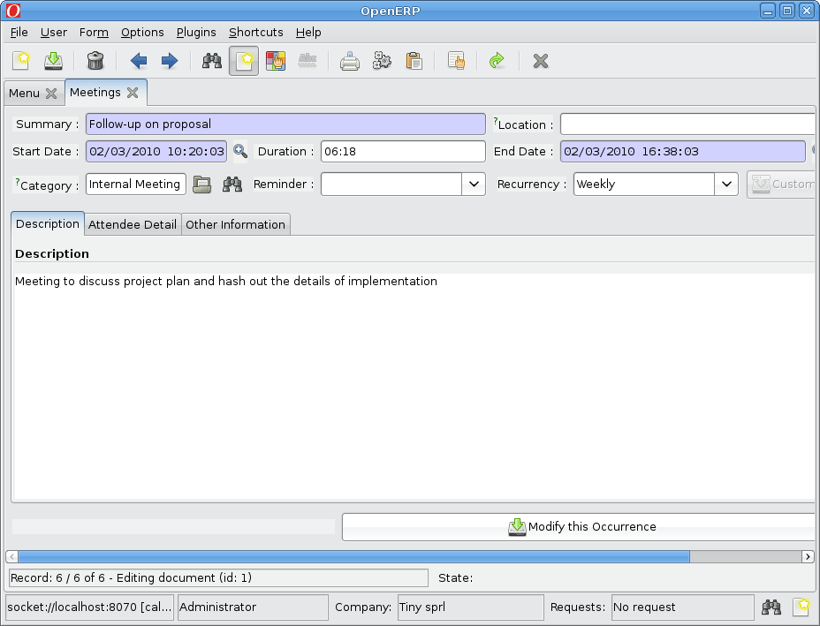

It will reflect on meeting's calendar view:

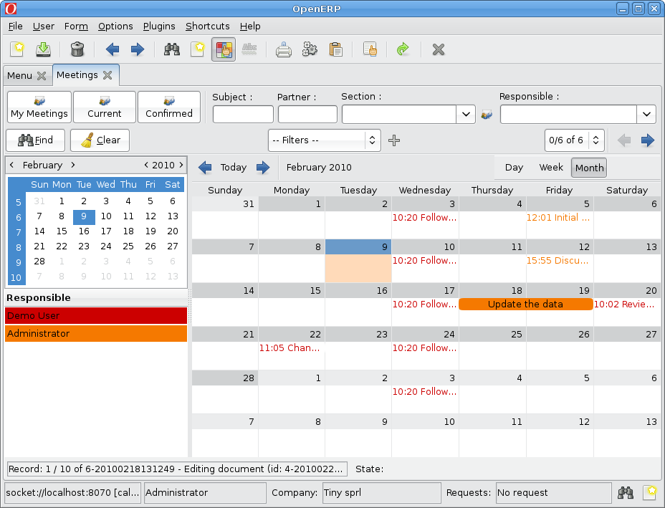
Defining Custom Recurrency:

Select Custom from the Recurrency selection box that will .
Here we defined that the event will occur every week on Tuesday and Friday for 15 times.
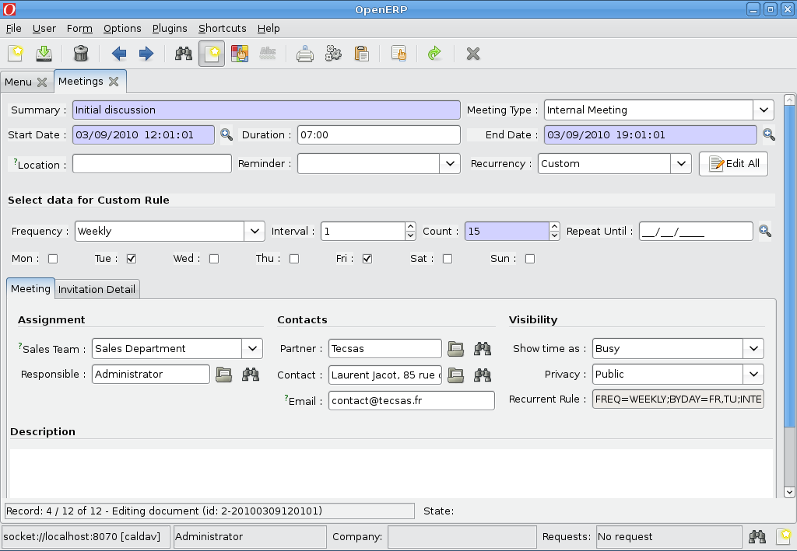
On the calendar view it will appear like:

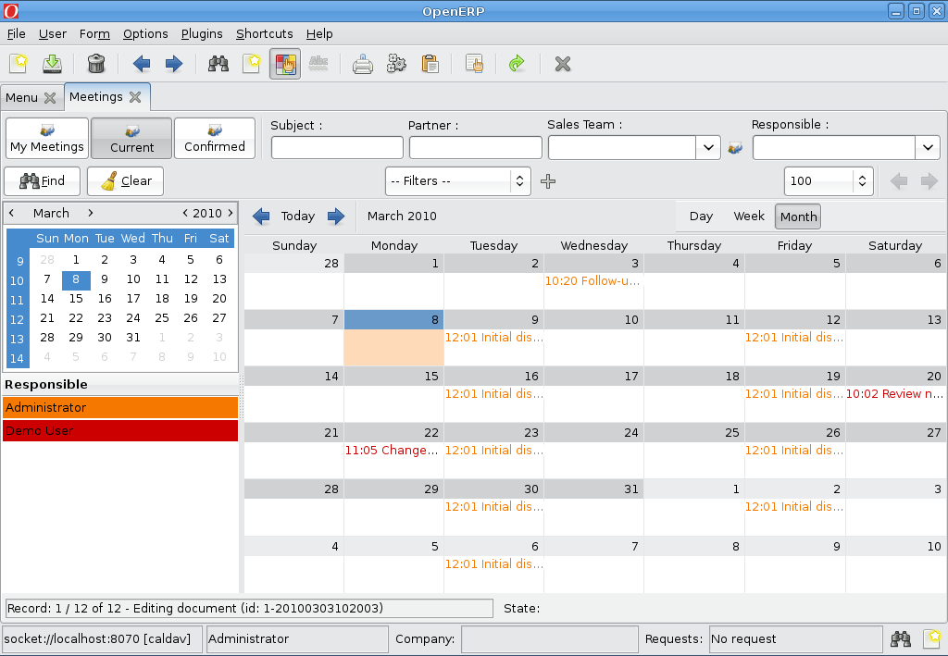

Editing any event from recurret events will edit only that occurence,
You can edit event details using “Edit All” button on the right of Recurrency field.
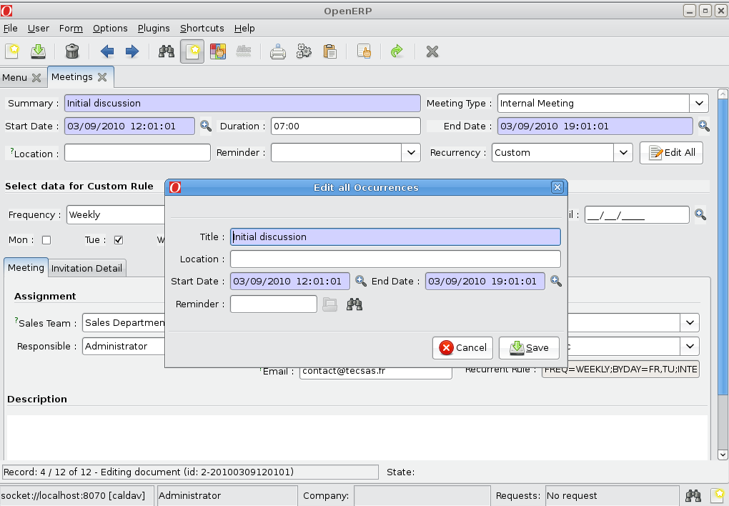
Event Reminder:
You can set event reminder from “Reminder” field, or define custom reminder from menu Sales/Configuration/Calendar/Available alarms.

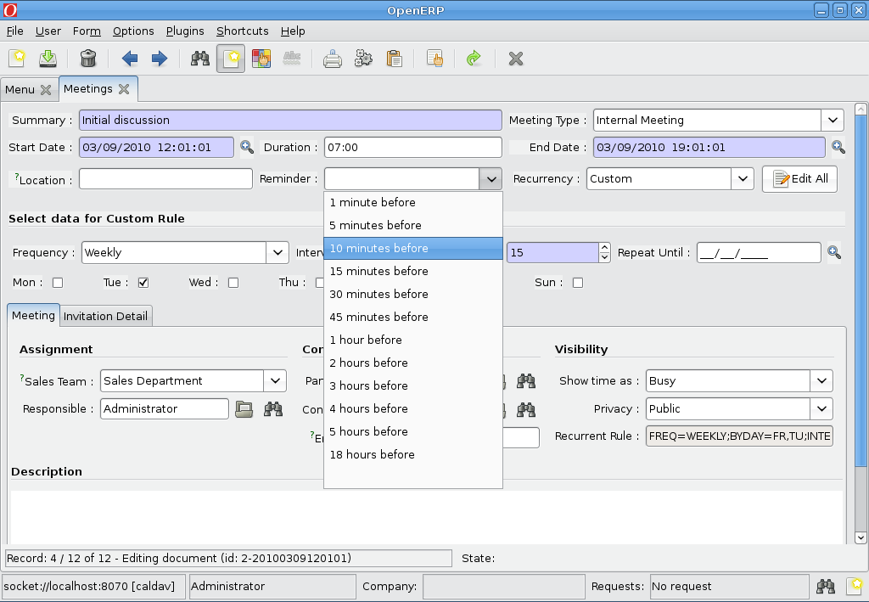
A scheduler is created to check for Event Reminder.
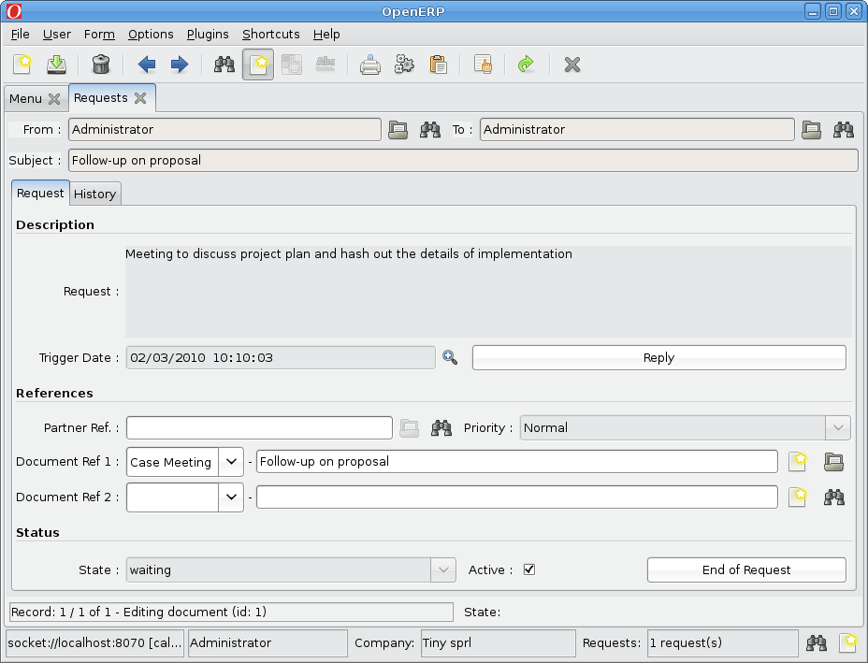
It will create a Request (res.request) on the Alarm trigger date-time.
Invite Attendee:

You can invite people for event or define assingee for task.
If you select boolean “Send Mail”, it will send an invitation mail.

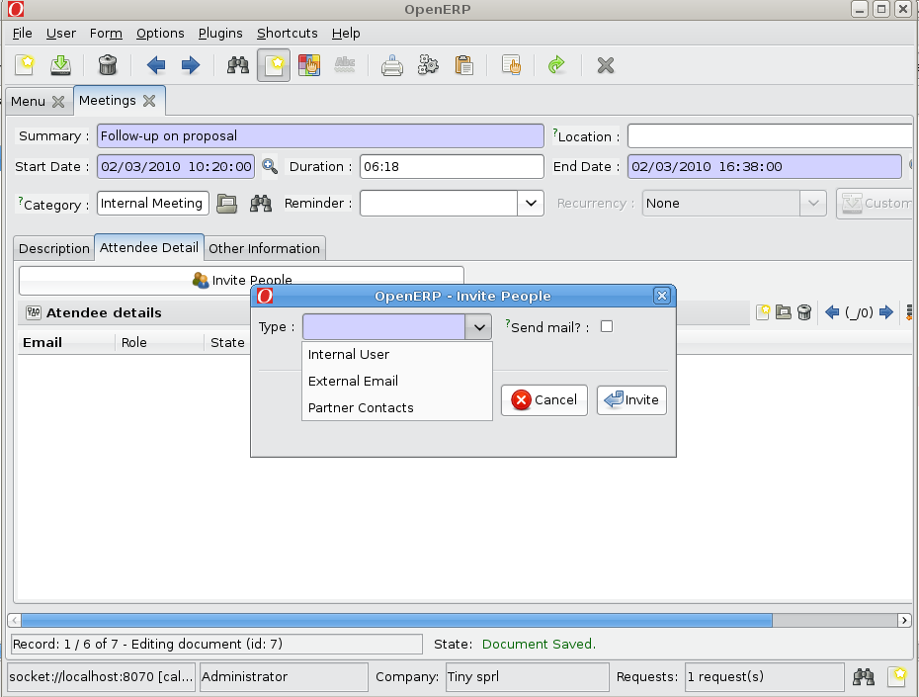
If you select boolean “Send Mail”, it will send an invitation mail.

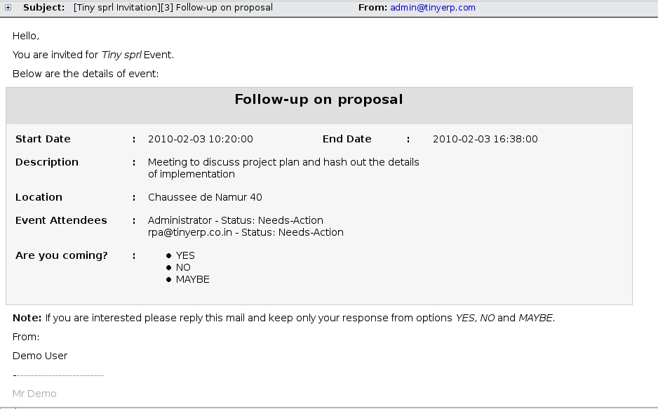
The invited people can reply for his response.
You can link this response with “Email Gateway” by creating gateway for “Attendee information” model.
This will chage attendee's status according to reply.

User will also check his invitation from menu Sales/Meetings/Meeting Invitations.
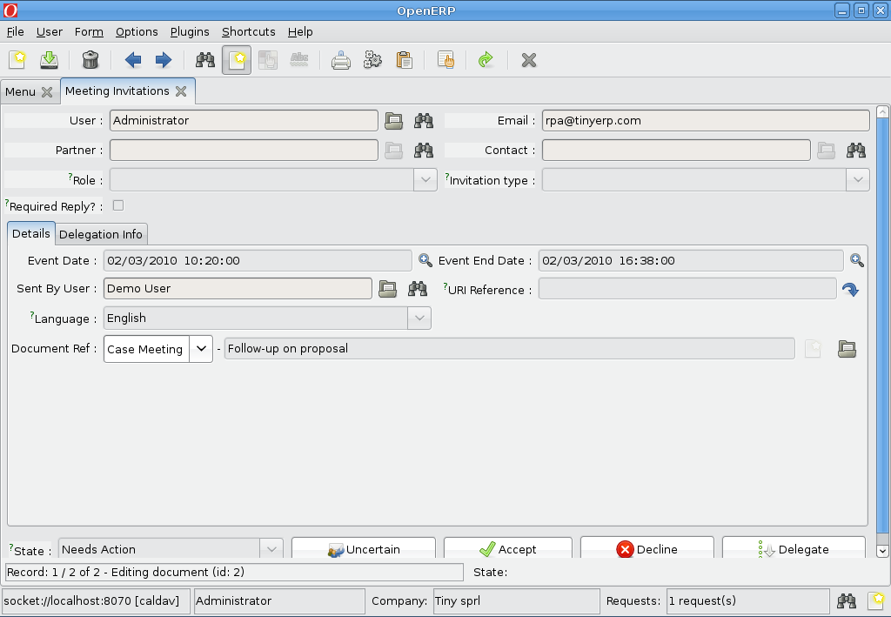
Define Gateway and Gateway Server:
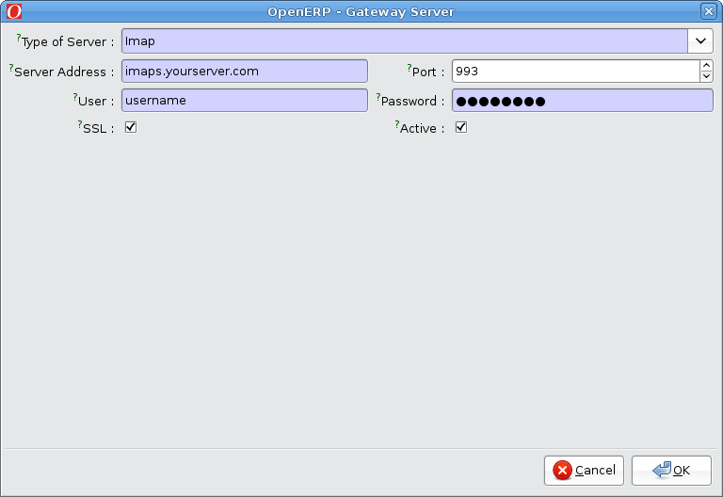
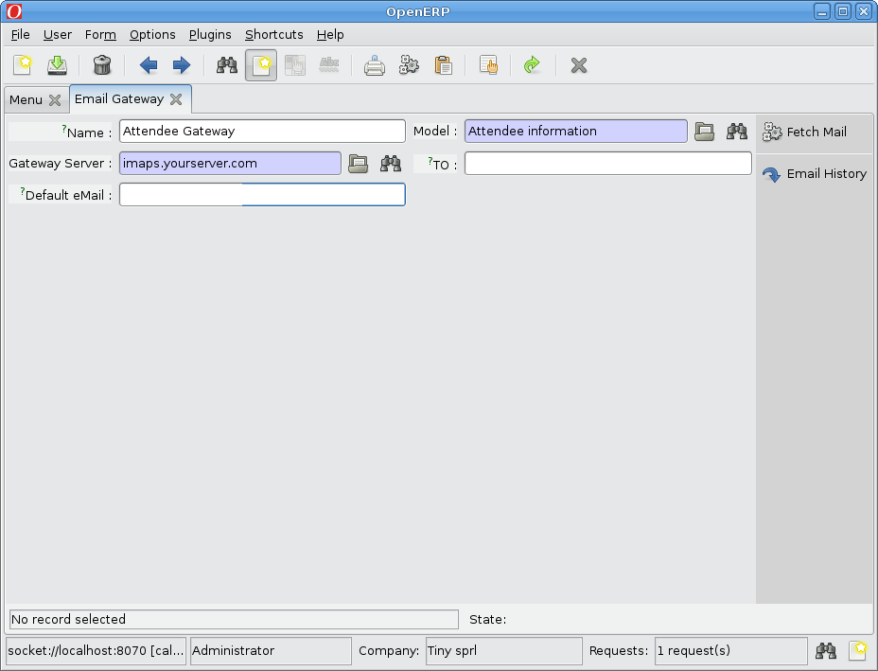
Synchronization with Sunbird:
Here is an example to synchronize OpenERP calendar into Mozilla sunbird.
You can access to a remote OpenERP calendar using webdav.
The URL path of calendar is defined as follow:
http://host:port(by default 8069)/calendar/dbname/calendar_name.ics
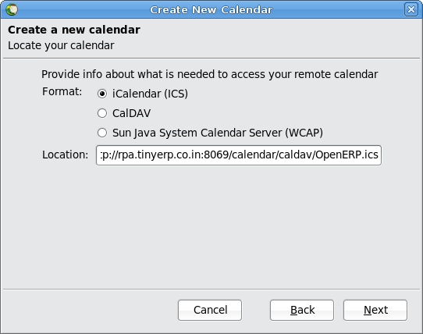

After subscribing it you can see OpenERP event and todo in sunbird.
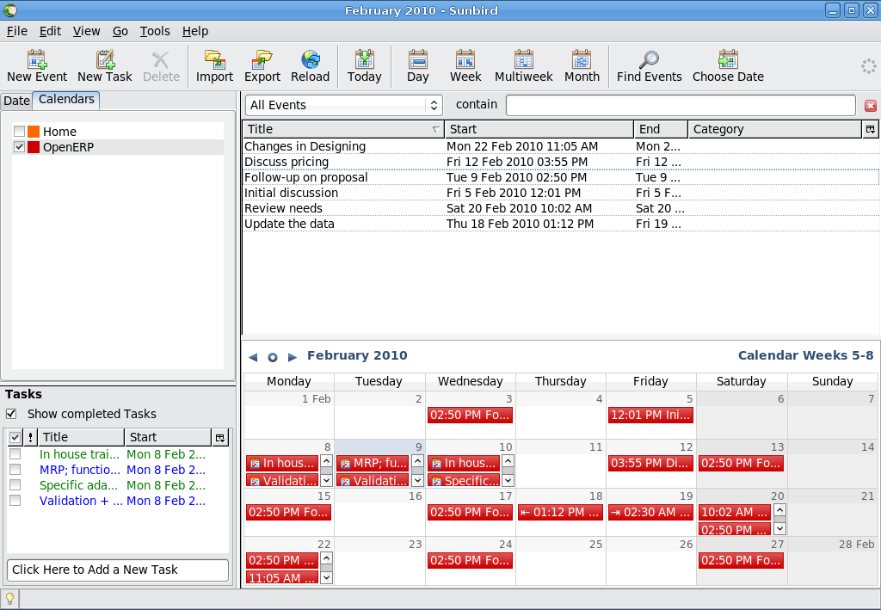
Creating/Updating task or event will reflect in OpenERP.
If we create event in Sunbird like:
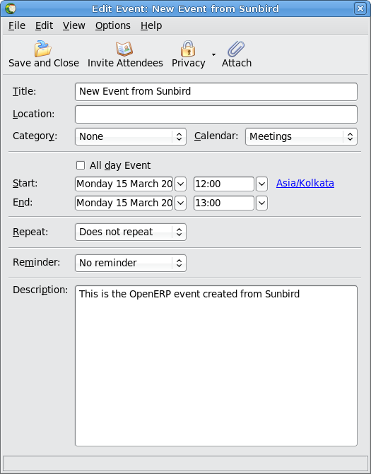
New event created in OpenERP:
